Name____________________________ Login ________________________Date________________________

1. **What must an operator have in their possession to enter the workcell?**
   1. Empty Pallet
   2. Interlock Key
   3. Eye protection
   4. None of the above
2. **What will happen if an operator has properly entered one side of the workcell while the robot is operating?**
   1. The robot will execute an emergency stop
   2. The robot will pause at the home position and not pick another tote until the operator leaves the cell.
   3. The robot will continue working on the other side of the workcell.
   4. The robot will continue working on both sides of the workcell.
3. **Who can be escorted into the cell without an interlock key in their possession?**
   1. The General Manager
   2. Loss Prevention
   3. No one
   4. Facilities
4. **What must be done in the rare instance you have to move between the robot and the inner light curtain to clear a fault?**
   1. The machine **must** be cycle stopped and the interlock key **must** be in the possession of the operator.
   2. The machine must be cycle stopped only.
   3. The operator **must** have the interlock key in possession only.
   4. The robot must be placed into maintenance mode.
5. **The condition of the pallet has no impact on how the robot will perform.**
   1. True
   2. False
6. **A light curtain is ___________________.**
   1. An invisible barrier that will emergency stop the robot if it is broken.
   2. What the robot uses to determine the position of the tote before being picked.
   3. An invisible measuring device the robot uses to determine overheight totes.
   4. A laser the robot uses to search for an empty location on the pallet.
7. **What will cause a tote to be placed into jackpot instead of palletized?**
   1. An overheight tote
   2. An empty tote that has no building destination assigned to it
   3. A tote that’s building destination is not assigned to one of the 8 robot pallet locations
   4. All of the above
8. **What will cause a tote to be placed into buffer instead of on a pallet?**
   1. An overheight tote
   2. A tote that is broken
   3. A tote that has a pallet location which is currently full and needs to be removed.
   4. An overweight tote
9. **What is a “robot detected product drop” Failure?**
   1. When the robot cannot pick up a tote at the infeed location.
   2. When the robot loses grip on the tote while moving and 2 sides of the EoAT sensors are not activated. The associate must call the Reliability and Maintenance Engineering team to correct this fault.
   3. When a tote cannot be placed to a pallet location
   4. None of the above
10. **What is a “Vision Error”?**
11. When the photo eyes on the conveyor cannot read a tote ID because it is damaged/scratched
12. When too many totes enter into pick infeed.
13. When the tote cannot be placed to a pallet location because the robot sees a problem with that location
14. When the robot loses grip on the tote while moving.
15. **How do you resolve a fault where multiple totes are in the pick infeed cell and the robot cannot grab the tote?**
    1. Use a reach pole from where the tote enters the cell to pull back the extra tote
    2. Run into the cell quickly without engaging the light curtain to move the tote
    3. Both A and B
16. **How does the robot identify overheight totes?**
    1. It doesn’t; overheight totes are processed the same as regular totes.
    2. By measuring the weight of the tote and making a mathematical calculation
    3. Using a camera to take an image of the product in the tote
    4. By using an overheight plate on the End of Arm Tool (EOAT)
17. **How do you identify a pallet’s destination / routing?**
    1. Ask your manager (who uses the Flow Sortation Tool and SSP Resource Management tool to verify)
    2. Go to the screen on the HMI that has the information
    3. It is stated on the pallet light
18. **What does it mean if the pallet light is lit and solid?**
    1. The pallet location is full, needs to be removed from the cell, and replaced with an empty pallet
    2. There is a nested tote on the pallet that requires attention
    3. There is an overheight tote on the pallet
    4. The pallet sensors are not blocked which means a pallet is either not fully loaded into the workcell or completely missing from the workcell
19. **What does it mean if the pallet light is lit and blinking?**
    1. The pallet location is full, needs to be removed from the cell, and replaced with an empty pallet
    2. There is a nested tote on the pallet that requires attention
    3. There is an overheight tote on the pallet
    4. The pallet sensors are not blocked which means a pallet is either not fully loaded into the workcell or completely missing from the workcell
20. **What happens if a full pallet of totes is pulled out of the cell and is replaced by an empty pallet?**
    1. The robot’s count of layers and totes on the pallet is automatically reset to 0 Totes
    2. The HMI must be updated manually to tell the robot how many layers and totes there are
21. **Scenario: You have to partially remove a pallet that has 10 totes on it out of its location (and pallet sensors) to clear a fault. Can you put the pallet with 10 totes back into that location?**
    1. Yes, because the robot knows what pallet was last in the cell
    2. No, because the robot will reset the pallet count to Layer 1, Totes 0. If you move a partially complete pallet out of the pallet sensors, you must always replace it with an empty pallet.
22. **Scenario: The robotic palletizer is sending all totes to jackpot, and they are not overheight or damaged. What could be a possible cause?**
    1. The robot has different destinations programmed in its 8 pallet locations than the destinations of all the totes. Notify your AM immediately
    2. The overheight plate is broken and incorrectly measuring all totes as overheight. Notify your AM/Facilities immediately
    3. The robot is updating its software, this should resolve itself within about 15 minutes and return to normal operating mode.
    4. Both A and B
23. **Label the diagram using the given list *and* number each pallet location correctly:**

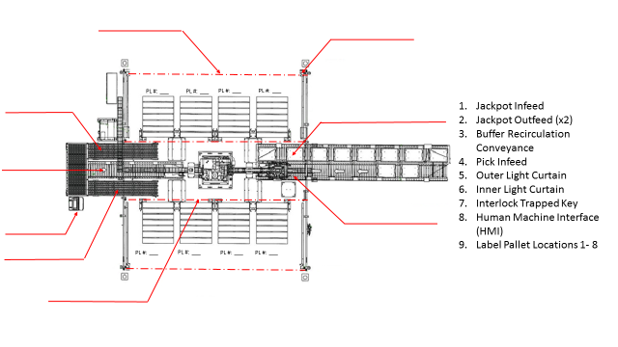

**Answer Key**

1. B – The student fails the test and cannot continue if they get this wrong.
2. C
3. C
4. A
5. A
6. A
7. D
8. C
9. B
10. C
11. A
12. D
13. A
14. A
15. D
16. A
17. B
18. D

